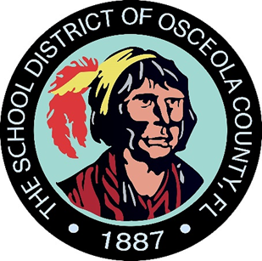

Gateway High School

**Literacy Night, Math/STEAM Night, College & Career Night**

**Date**: Friday, May 2nd, 2025

**Time:** 5:30 p.m.

**Location:** Building 1

(Administration Front Lobby)

**Agenda:**

Come explore many parent resources to help your students from home.

* Guidance Counselors
* Technical College
* Testing/EOC “Cheat Sheets” for Review
* Graduation requirements
* Academic Resources based on Standards
* College Fair
* Summer School Information

**We will provide refreshments!**

